**The compressed folders are** kept **at following location:**

\\10.65.9.206\ProjectManagementOffice\employees\nilesh\isO 27001 Audit Artefacts\dbA\Perfmon setup

Following steps for **pssd_2016_gp**

**Step 1:**Open a command prompt under administrator credentials, this account MUST BE part of Local Administrators and also SQL Administrator. Change the current directory to your PSSDIAG folder and run pssd.exe to extract its contents.

Example:

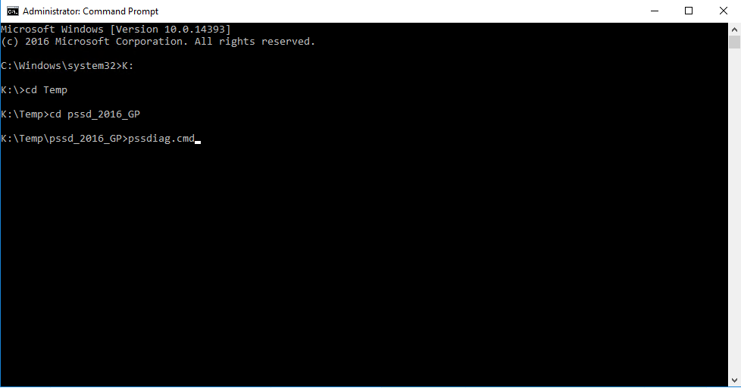

Step 2:

Run PSSDIAG.CMD at the command prompt to start the collection process.

Step 3:

Once PSSDIAG displays the message, “Collection started,” attempt to reproduce your issue.

Step 4:

Stop PSSDIAG by pressing CTRL+C once. Wait for the collector to shutdown

Step 5:

When questioned to stop the batch file answer “Y”, this will cleanly shut down the collector.

Step 6:

Compact and upload the contents of the ..\OUTPUT folder in the PSSDIAG install directory